CST 356 - Web Development

Jan 23, 2021 Sat

Jihyuk Chung

**Lab 2: Containers**

Docker Hub registry account: https://hub.docker.com/u/hyunwinter

Installation)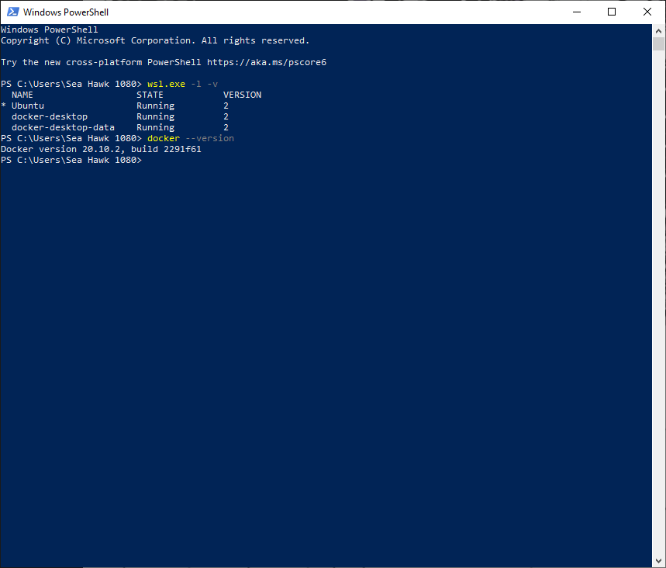

Exercise 1) 1 ~ 3

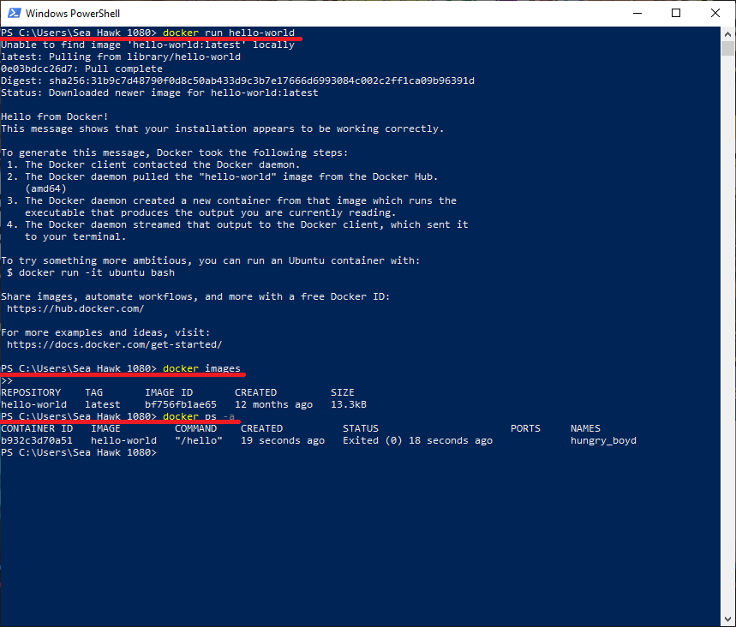

Exercise 2) 1.0 ~ 1.1

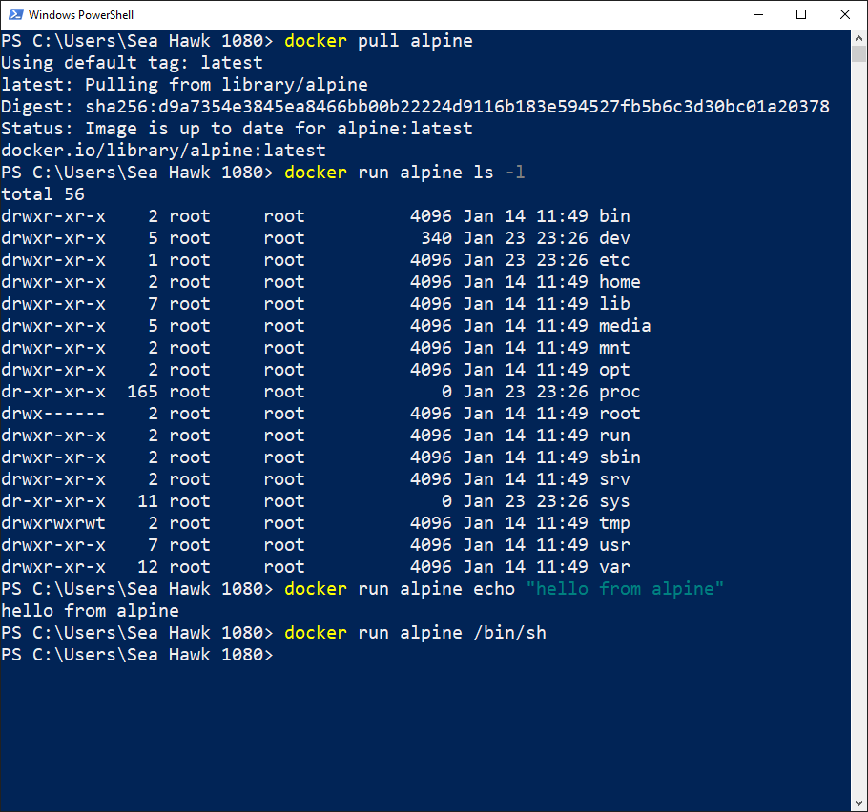

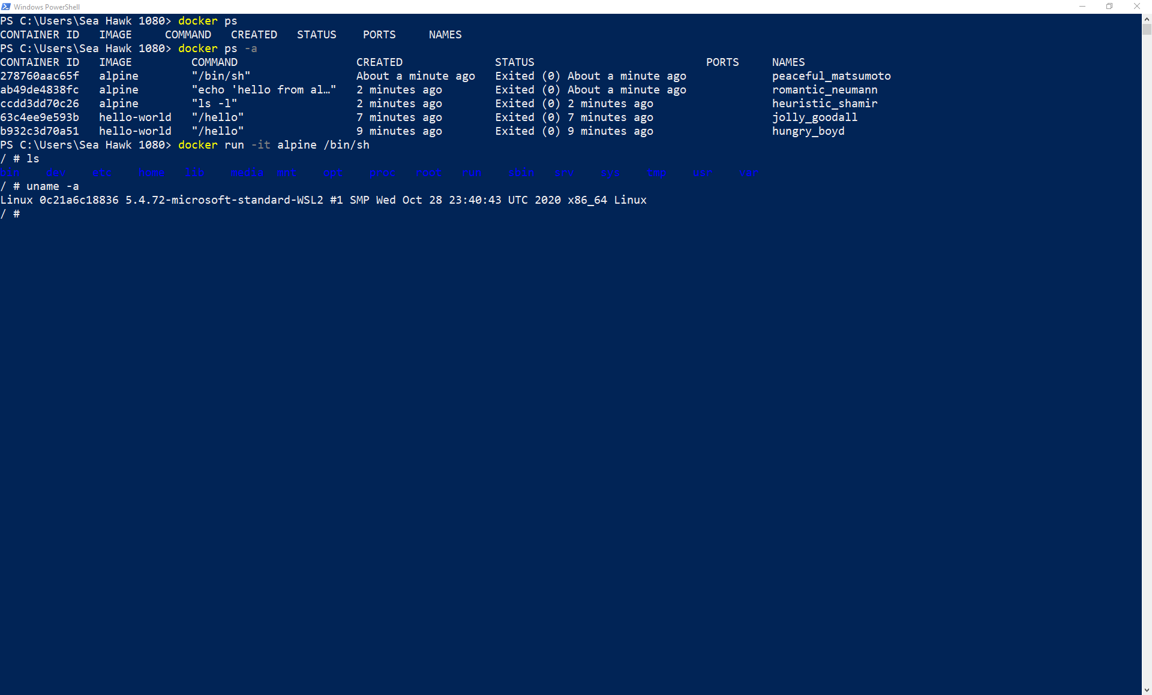

Exercise 3) 2.1: Run a static website in a container

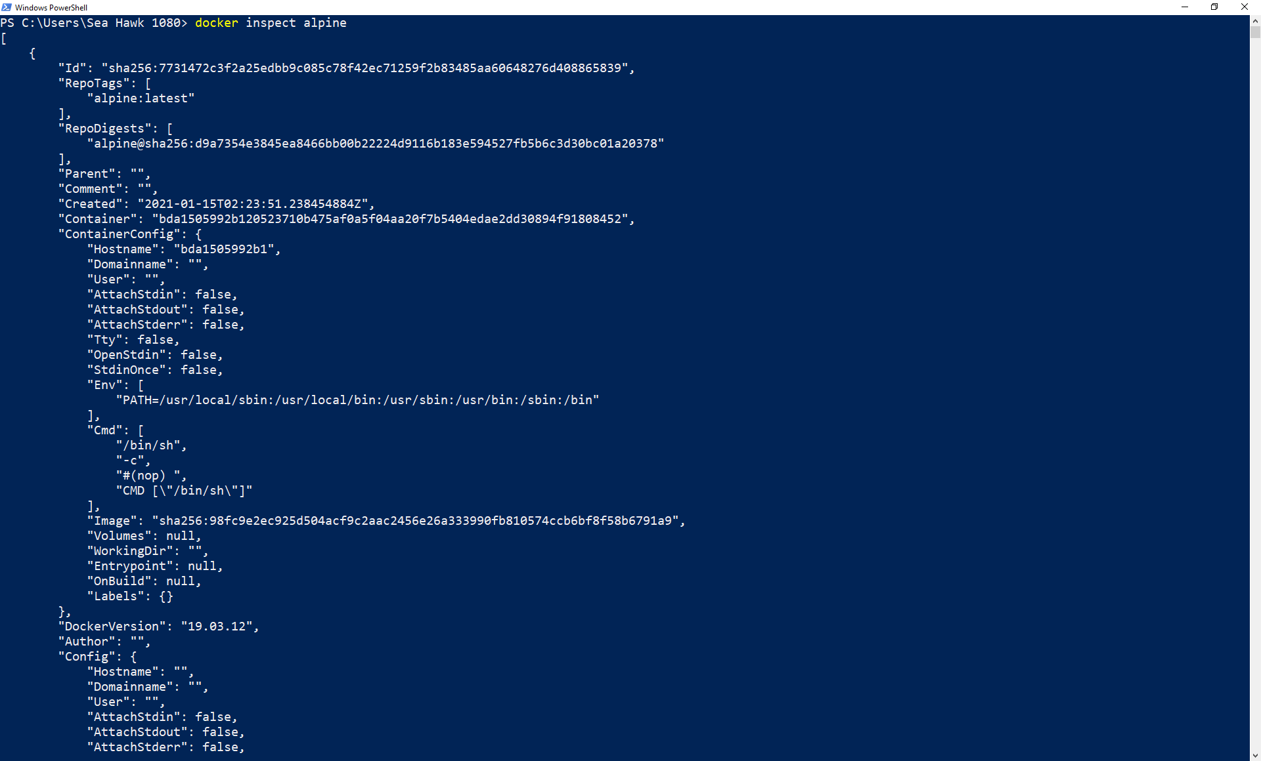

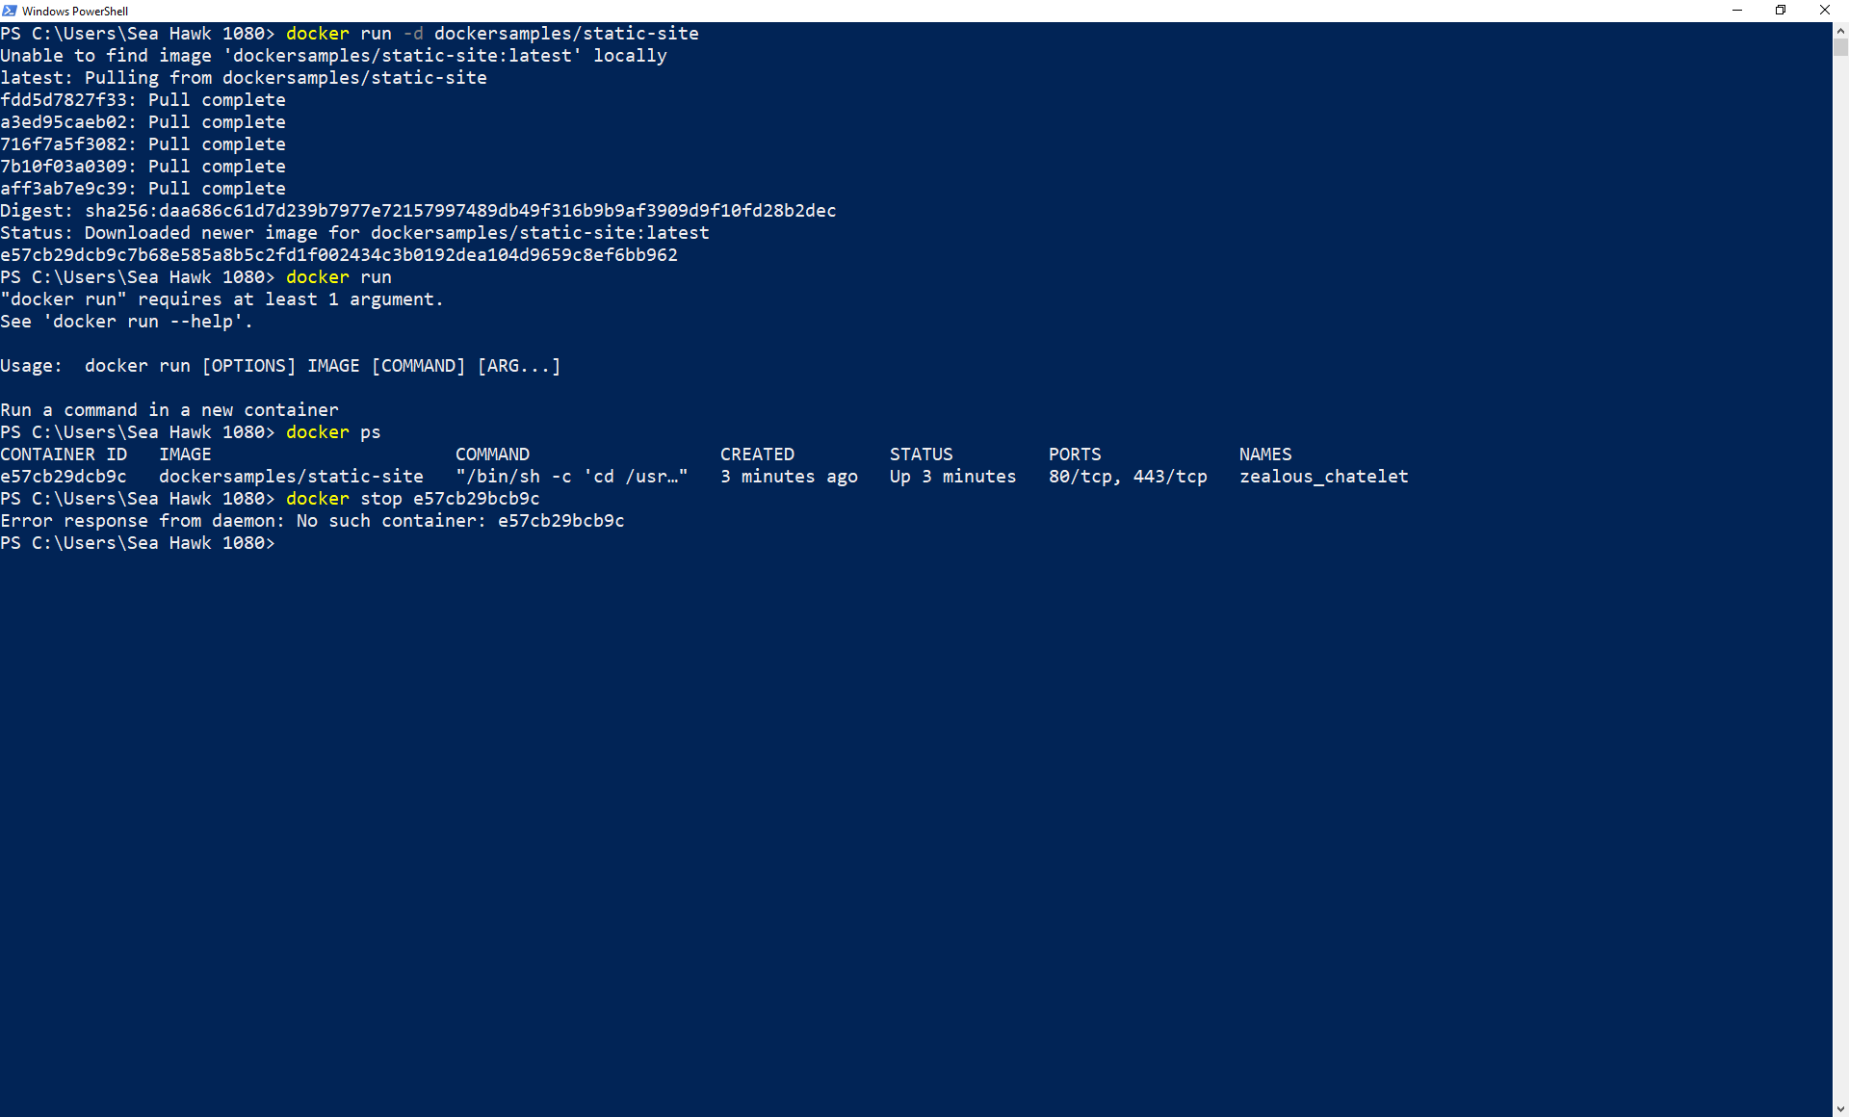

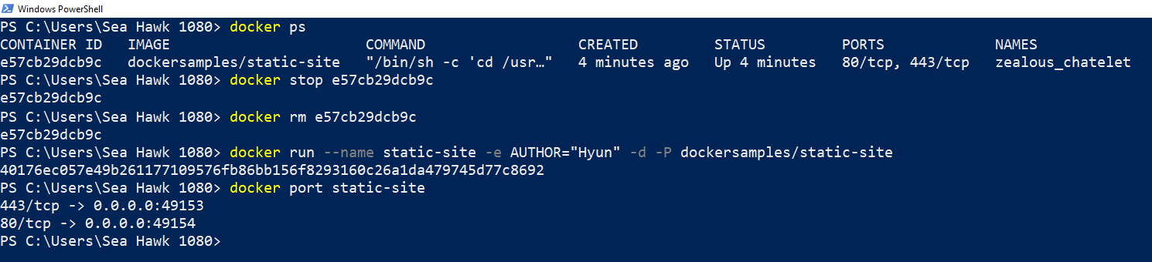

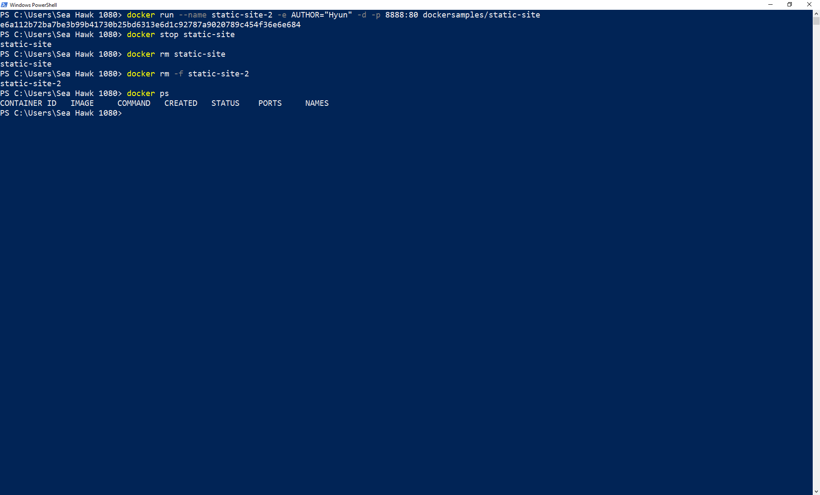

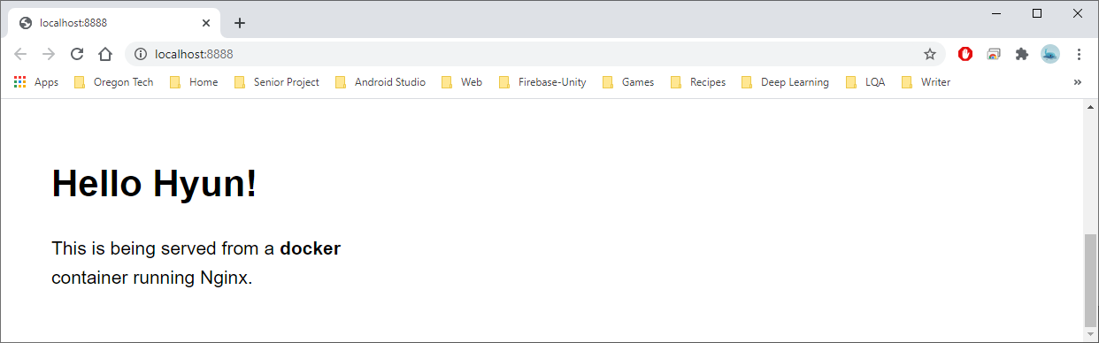

Exercise 3) 2.2: Docker Images

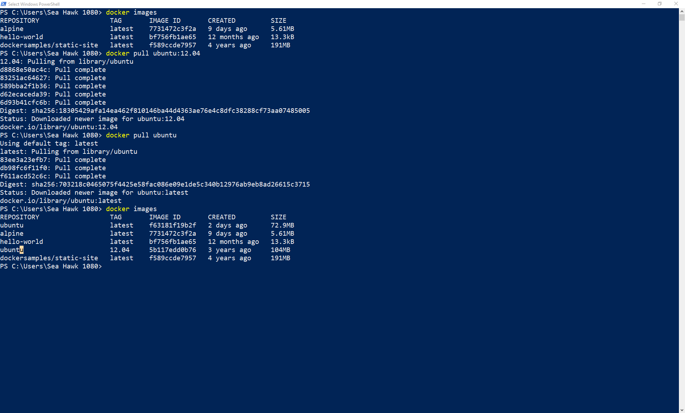

Exercise 3) 2.3.2: Build the image

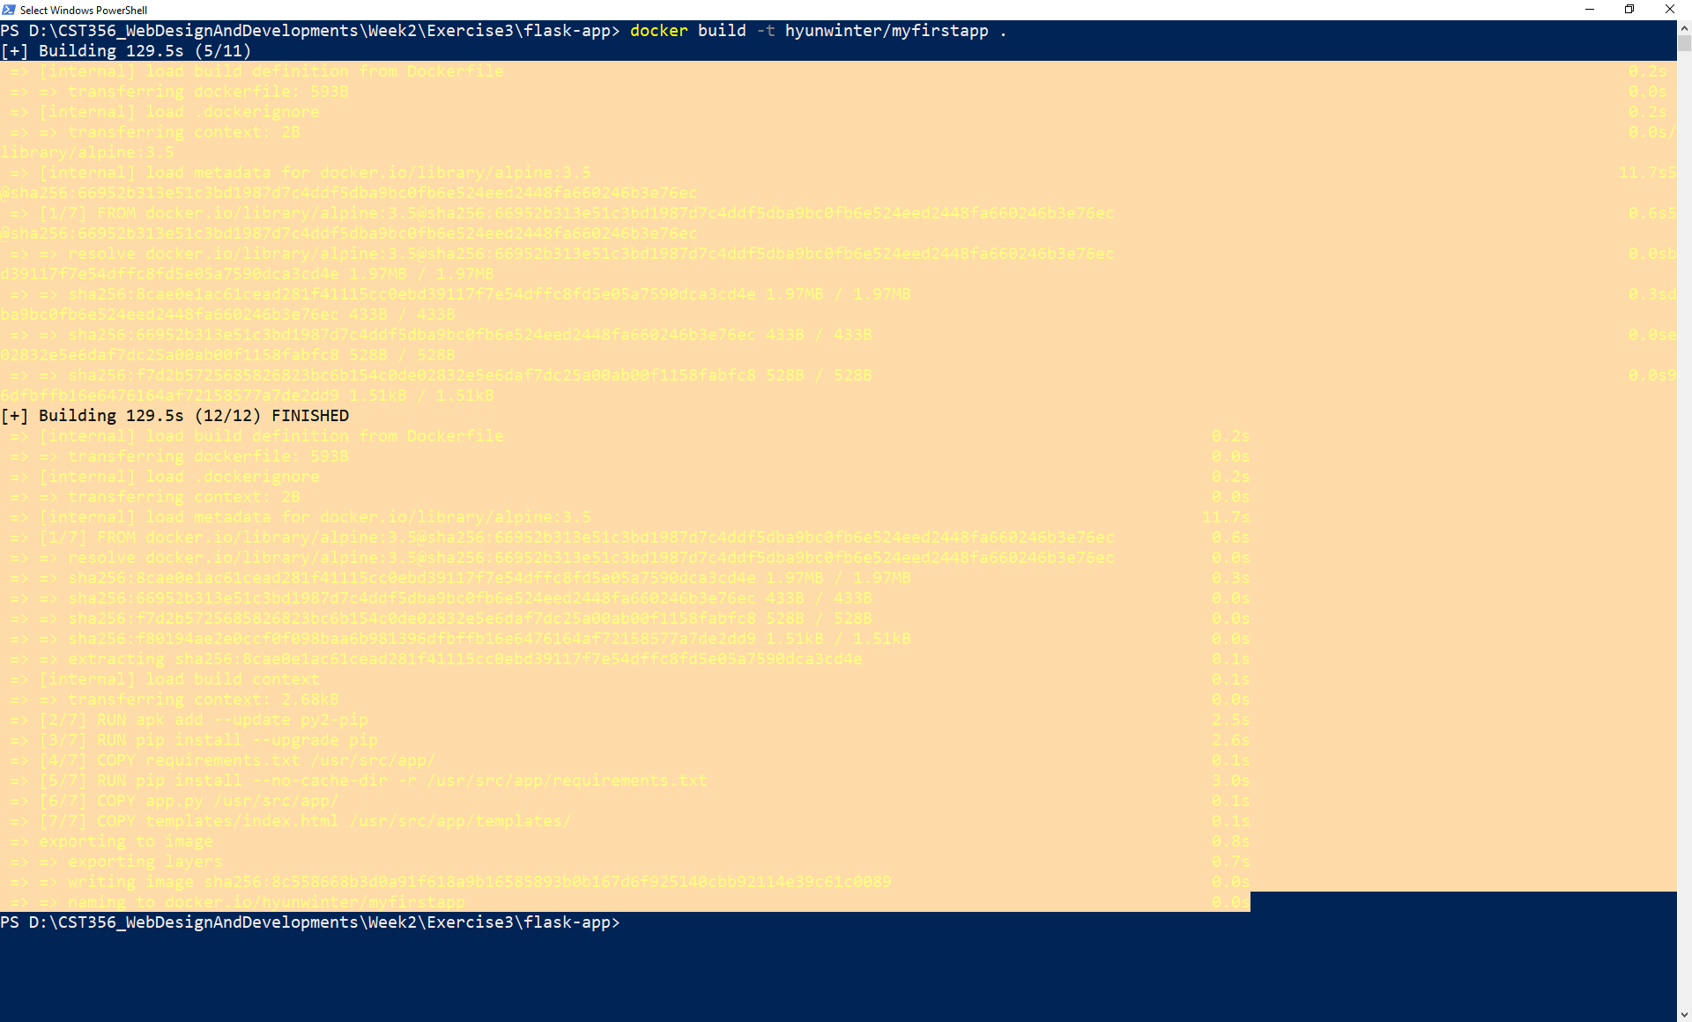

Exercise 3) 2.3.3: Run your image

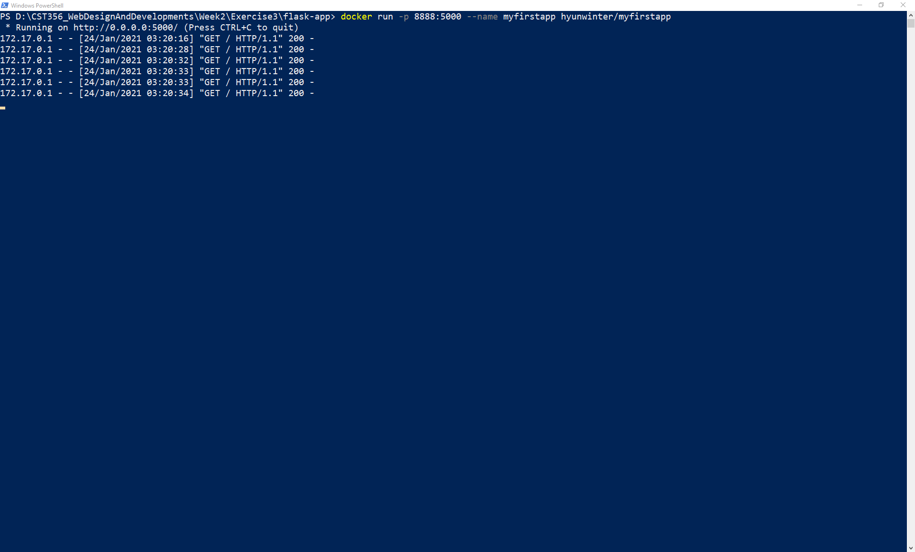

Unfortunately, it seems like the images are no longer maintained.

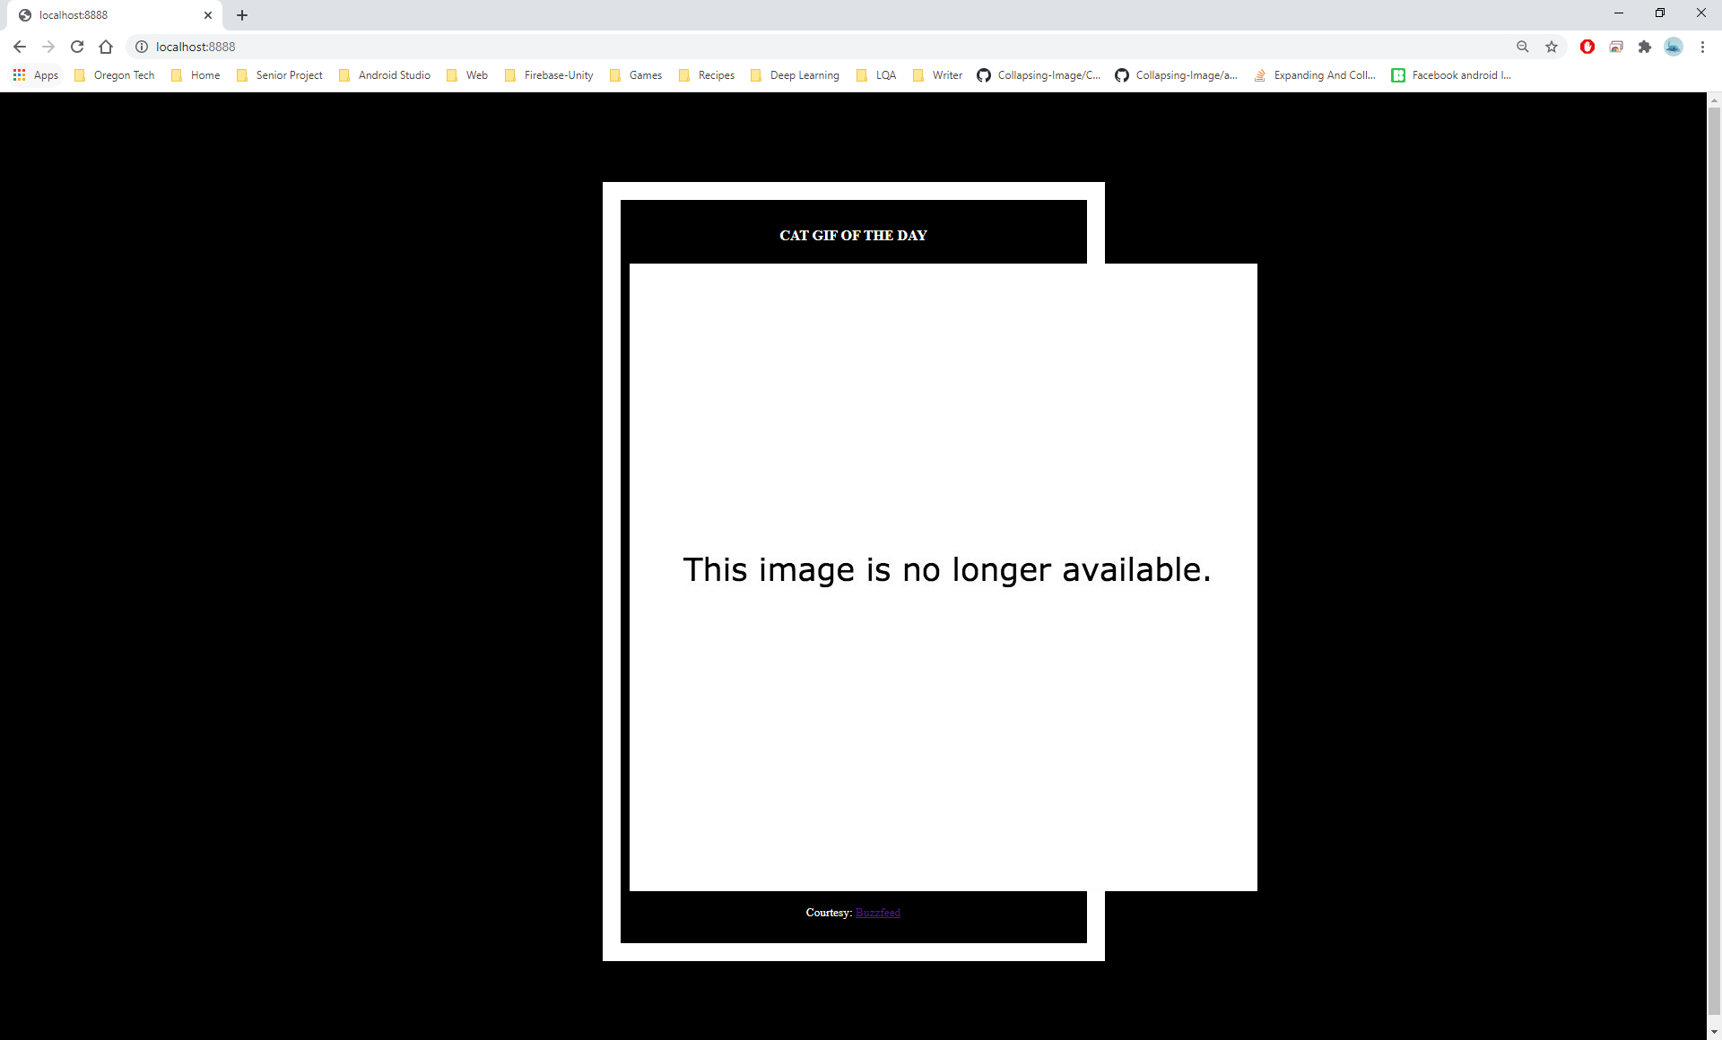

So I fixed it with different links.

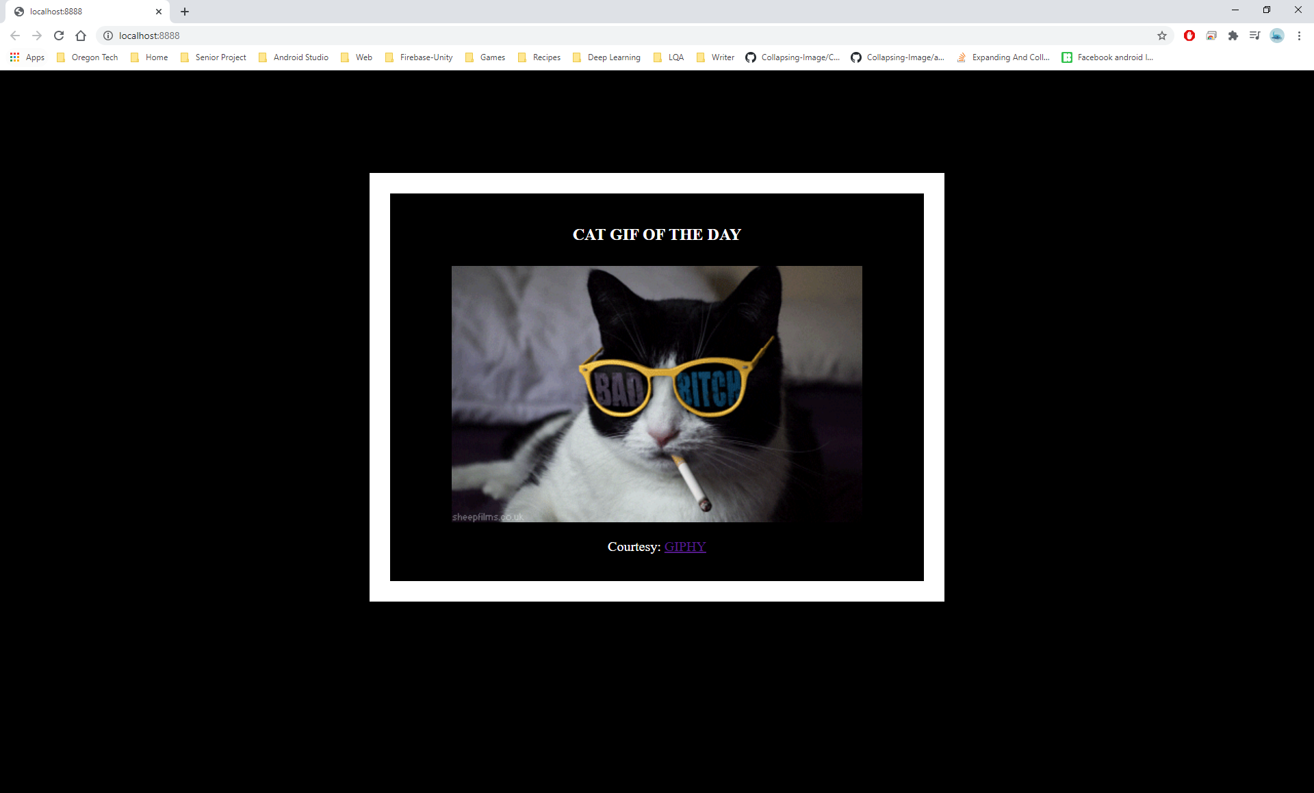

Exercise 3) 2.3.4: Push your image

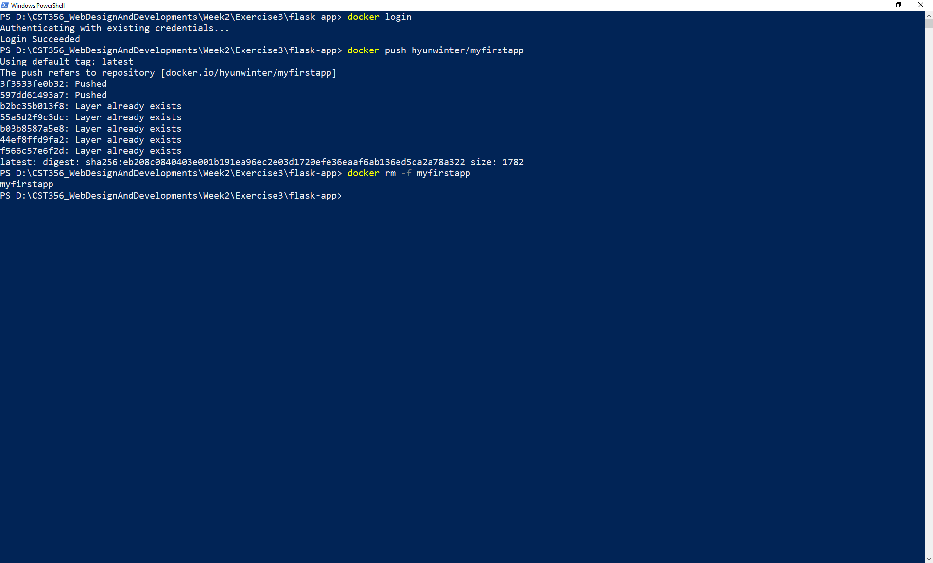

Exercise 4)

